|  |  |  |  |  |  |  |  |  |  |  |  |  |  |
| --- | --- | --- | --- | --- | --- | --- | --- | --- | --- | --- | --- | --- | --- |
|  |  |  |  |  |  |  | **ANEXO N° 03**  **PERFIL DEL PUESTO** | | | | | | |
| **IDENTIFICACIÓN DEL PUESTO** | | | | | | | | | | | | | |
| Órgano | | | | | |  | | | | | | | |
| Unidad Orgánica | | | | | |  | | | | | | | |
| Puesto Estructural | | | | | |  | | | | | | | |
| Nombre del puesto: | | | | | |  | | | | | | | |
| Dependencia jerárquica lineal: | | | | | |  | | | | | | | |
| Dependencia funcional: | | | | | |  | | | | | | | |
| Puestos a su cargo: | | | | | |  | | | | | | | |
|  |  |  |  |  |  |  |  |  |  |  |  |  |  | |
| **MISIÓN DEL PUESTO** | | | | | | | | | | | | | |
|  | | | | | | | | | | | | | |
|  |  |  |  |  |  |  |  |  |  |  |  |  |  | |
| **FUNCIONES DEL PUESTO** | | | | | | | | | | | | | |
| 1 |  | | | | | | | | | | | | |
| 2 |  | | | | | | | | | | | | |
| 3 |  | | | | | | | | | | | | |
| 4 |  | | | | | | | | | | | | |
| 5 |  | | | | | | | | | | | | |
| 6 |  | | | | | | | | | | | | |
| 7 |  | | | | | | | | | | | | |
| 8 |  | | | | | | | | | | | | |
| 9 |  | | | | | | | | | | | | |
| 10 |  | | | | | | | | | | | | |
|  |  |  |  |  |  |  |  |  |  |  |  |  |  | |
| **COORDINACIONES PRINCIPALES** | | | | | | | | | | | | | |
| Coordinaciones Internas: | | | | | | | | | | | | | |
|  | | | | | | | | | | | | | |
| Coordinaciones Externas: | | | | | | | | | | | | | |
|  | | | | | | | | | | | | | |

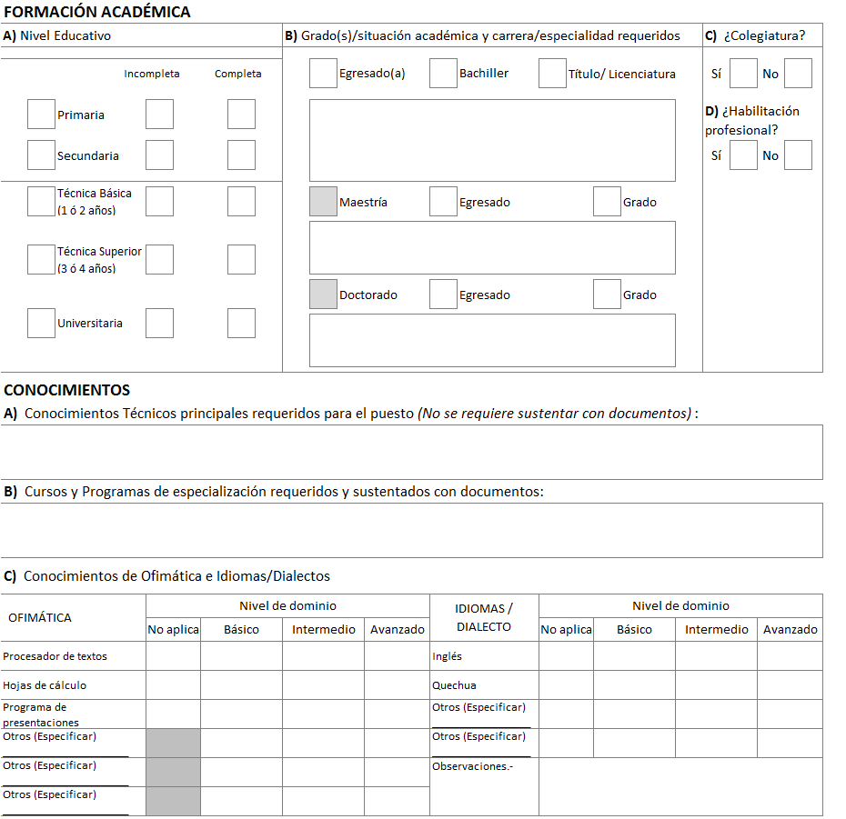

|  |  |  |  |  |  |  |  |  |  |  |  |  |  |  |  |  |  |  |  |  |  |  |  |  |  |  |  |  |  |  |  |  |  |  |  |  |  |  |  |  |  |  |  |  |  |  |
| --- | --- | --- | --- | --- | --- | --- | --- | --- | --- | --- | --- | --- | --- | --- | --- | --- | --- | --- | --- | --- | --- | --- | --- | --- | --- | --- | --- | --- | --- | --- | --- | --- | --- | --- | --- | --- | --- | --- | --- | --- | --- | --- | --- | --- | --- | --- |
| **EXPERIENCIA** | | | | | |  |  |  |  |  |  |  |  |  |  |  |  |  |  |  |  | |  | | |  | |  | |  | |  | | |  | | |  | |  | | |  | | | |
| Experiencia general Indique el tiempo total de experiencia laboral; ya sea en el sector público o privado. | | | | | | | | | | | | | | | | | | | | | | | | | | | | | | | | | | | | | | | | | | | | | |
|  | | | | | | | | | | | | | | | | | | | | | | | | | | | | | | | | | | | | | | | | | | | | | |
| Experiencia específica | | | | | | | | | | | | | | | | | | | | | | | | | | | | | | | | | | | | | | | | | | | | | |
| **A.** Indique el tiempo de **experiencia requerida para el puesto** en la función o la materia: | | | | | | | | | | | | | | | | | | | | | |  | | |  | |  | |  | |  | | |  | | |  | |  | |  | | | |  |
|  | | | | | | | | | | | | | | | | | | | | | | | | | | | | | | | | | | | | | | | | | | | | | |
| **B.** En base a la experiencia requerida para el puesto **(parte A)**, señale el tiempo requerido en el **sector público**: | | | | | | | | | | | | | | | | | | | | | | | | | | | | | | | | | | | | | | | | | | | | | |
|  | | | | | | | | | | | | | | | | | | | | | | | | | | | | | | | | | | | | | | | | | | | | | |
| **C.** Marque el **nivel mínimo de puesto** que se requiere como experiencia; ya sea en el sector público o privado: | | | | | | | | | | | | | | | | | | | | | | | | | | | | | | | | | | | | | | | | | | | | | |
| Practicante profesional | |  |  | Auxiliar o Asistente | |  |  | Analista | |  |  | Especialista | | |  |  | Supervisor / Coordinador | | |  | |  | | Jefe de Área o Departamento | | | | | | |  | |  | | | Gerente o Director | | | | | |  | |  | | | |
| *\* Mencione* ***otros aspectos complementarios sobre el requisito de experiencia****; en caso existiera algo adicional para el puesto.* | | | | | | | | | | | | | | | | | | | | | | | | | | | | | | | | | | | | | | | | | | | | | |
|  | | | | | | | | | | | | | | | | | | | | | | | | | | | | | | | | | | | | | | | | | | | | | |
|  |  |  |  |  |  |  |  |  |  |  |  |  |  |  |  |  |  |  |  |  |  | |  | | |  | |  | |  | |  | | |  | | |  | |  | | |  | | | |
| **HABILIDADES O COMPETENCIAS** | | | | | | | | | | | | | | | | | | | | | | | | | | | | | | | | | | | | | | | | | | | | | |
|  | | | | | | | | | | | | | | | | | | | | | | | | | | | | | | | | | | | | | | | | | | | | | |
|  |  |  |  |  |  |  |  |  |  |  |  |  |  |  |  |  |  |  |  |  |  | |  | | |  | |  | |  | |  | | |  | | |  | |  | | |  | | | |
| **REQUISITOS ADICIONALES** | | | | | | | | | | | | | | | | | | | | | | | | | | | | | | | | | | | | | | | | | | | | | |
|  | | | | | | | | | | | | | | | | | | | | | | | | | | | | | | | | | | | | | | | | | | | | | |